Why Altrusa?  - A literacy based international service organization that provides a unique opportunity to use your time and talent to enrich the lives of others.  - We offer an environment to develop friendships with like-minded individuals.  - As an Altrusan, you will work on meaningful projects in your community and develop additional leadership skills.  Why Altrusa? Learn more at: {insert local website}  Why Altrusa? Learn more at: {insert local website} | Company Name  Street Address  City, ST ZIP Code | Recipient Name  Address  City, ST ZIP Code | {Insert Local Club}  An International Organization of Professionals Dedicated to Community Service  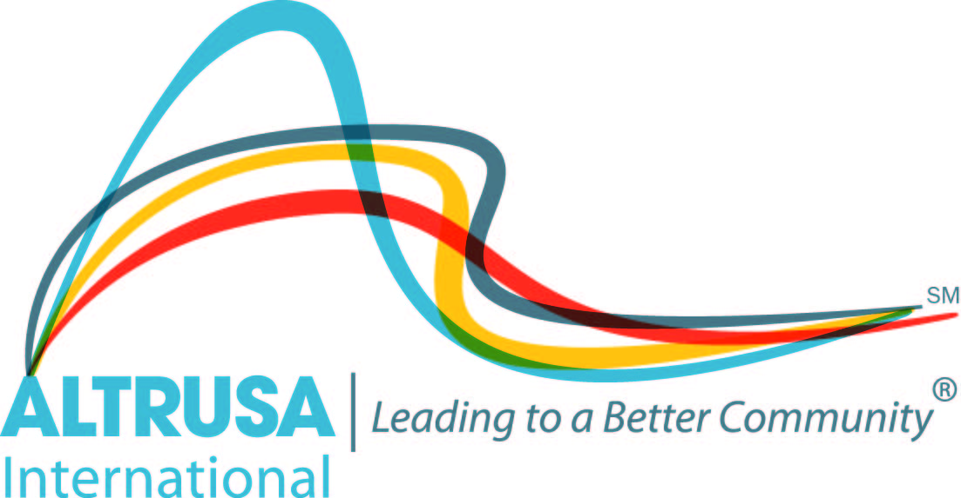

Contact Us  Company Name  Street Address  City, ST ZIP Code  Telephone  Email  Website  Altrusa- Leading To A Better Community  - Altrusa’s goal as an organization is to improve literacy, which is the key to providing opportunities for those we serve.  - Altrusa International has more than 400 clubs and membership of over 10,000 in 19 countries and territories.  - Our members have a variety of occupations and lifestyles, but all share a sincere interest in community service. | The {insert city} Club  We are dedicated to making {insert city or area} a better community in which to live. We actively assess the needs of our community and strive to meet some of those needs.  {add more about your club}  {insert your own picture}  Local Projects:  List some of your local projects. | Local Projects  Altrusa International of {insert city}, Inc. is involved in numerous community projects. Some of those projects are:  - {Specific projects}

